Payroll Department Time Reporting/Approval Policy

Policy Statement:
This policy provides guidance to employees, and their Time Approvers regarding the
reporting and approval of hours worked and absences.

Reason for Policy:
Timely and accurate reporting and approval of hours worked and absences taken are
Important for many reasons. Timely and accurate reporting helps to ensure that
employees are paid the correct amount timely and in accordance with wage and hour
laws. If time isn’t properly entered and approved by the stated deadline, the employee
may not receive the correct wages. Employees are inconvenienced and may suffer
financial hardship if their full paycheck is not received on time.

Procedures:
Employees who are non-exempt must report their hours worked and absences on a weekly basis by the deadline stated in the Payroll Calendar. All non-exempt (hourly) employees are paid on a weekly basis. Each work week begins at 12:00 a.m. Thursday and ends at 11:59 p.m. Wednesday. Paychecks are distributed on Wednesday, one week following the end of the pay period.
Employees report time data through their self-service timesheet or by use of a time clock and attest to the accuracy of that data. Knowingly submitting inaccurate time data is illegal under the Fair Labor Standards Act.
All non-exempt (hourly) employees report all time worked, including time worked over 40 hours, as well as leave time if applicable per week. Non-exempt employees should enter the number of hours worked on a daily basis. For example, if an employee works 8 hours, they will enter an 8 for that particular day.
- Hours worked should be coded as 'REGULAR PAY'
- Hours taken as vacation should be coded as 'VACATION'
- Hours taken as sick leave should be coded as 'SICK'*
- Hours taken as floating holiday should be coded as 'FLOATING HOLIDAY'
- Hours taken for funerals should be coded as 'FUNERAL LEAVE'
- For employees working a 35-hour week, the first 5 hours of overtime for that week will be paid at straight time and should be coded as 'REGULAR'
- Any hours worked over 40 in a week will be paid at the overtime rate and should be coded as 'REGULAR'
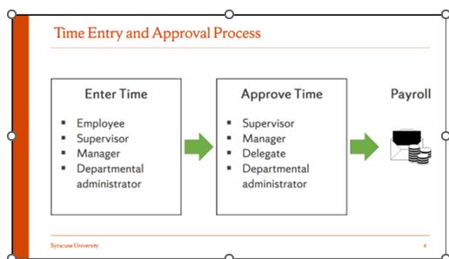
Employees (Time Reporters) are responsible for reporting time worked and absences taken by the posted deadline each week. Employees should obtain approval prior to working overtime hours.
Time Approvers (supervisors) are responsible for approving employee’s time and absences by the posted deadline each week. Supervisors who approve the reported time must have direct/personal knowledge of the hours worked and are responsible for edits, deletions, or corrections to ensure the time data is accurate. When Time Approvers approve time, they are certifying the employee did work the reported hours reported. Records of such should be kept by the supervisor or by the employee’s department.
Supervisors who have employees that use time clocks are responsible for quickly correcting “missed punches” (when an employee forgets to clock in or out) within the time clock system.
Department and Unit administrators are responsible for monitoring reported time for employees and should act as a back-up for the supervisor in the event they are unable to perform the required time reporting and/or approval tasks.
Exempt employees, excluding faculty and graduate assistants, report exception time data through their self-service timesheet, such as vacation, sick, etc. This time also requires approval from the direct supervisor who has knowledge of the absence.

